**Chapter 1**

**INTRODUCTION**

1. **Introduction**
   1. **About The Company**

**National Information Center (NIC)**

National Informatics Centre (NIC) under the Ministry of Electronics and Information Technology (MeitY) is the technology partner of the Government of India. It was established in 1976 with an objective to provide technology-driven solutions to Central and State Governments in various aspects of development. NIC has been instrumental in adopting and providing Information and Communication Technology (ICT) and eGovernance support to Central Government.

NIC has also developed several digital platforms for the socio-economic development of the country with ‘One-Nation One-Platform’ initiative to empower citizens digitally. Its services have created a perfect interaction of the Government with citizens, Government employees and businesses. With an objective of focused study of new technology, explore and experiment their use in governance, NIC has set-up Centre of Excellence (CoE) in Data Analytics, Artificial Intelligence, Blockchain and Application Security.

National Information Centre (NIC) Mantralaya, New Raipur Chhattisgarh. NIC has played an important role of an active catalyst and facilitator in informatics development programmed in Governments at the national, state and district levels, during the last 27 years.

The efforts of NIC Chhattisgarh for providing start-of-the art e-Governance solutions to state government, district government and citizen of Chhattisgarh have been recognized with various prestigious awards at National, State and District level. Chhattisgarh state center (CGSC), of NIC was setup at Raipur, in the year 2001 to provide the ICT (Information & Communication Technologies) services to government departments and organizations.

NIC Chhattisgarh, Department of Electronics And Information Technology, Government of India is providing network backbone and e-Governance support to Chhattisgarh State Government and Districts .National Informatics Center is a premier organization in the field of Information Technology (IT) in India. NIC implementing IT

Projects for both Central Government and State Government in the areas of:

(a) Central sector

(b) State sector

(c) District

District centers are operational in the districts with state of the art VC studios, high speed NICNET connectivity and DIO/DIA to manage the district centers activities and support various e- Governance initiatives for achieving targeted goal of delivering efficient citizen services to the common public in the State.

NIC has been instrumental in adopting Information and Communication Technology to reach out to India i.e. by implementing IT applications in Social and Public Administrations.

NIC supporting several services & projects such as bio-metric attendance, cloud, e-office, messaging, network, cyber security, VC, Webcast data center.

* 1. **About the Project**

**Project Title: “Uni-Connect”.**

**OBJECTIVE AND SCOPE OF THE PROJECT**

This project is developed for the fulfilment of various objectives had been decided primarily when the project was under planning.

The main objectives of this project are :-

* To create a user-friendly website that provides detailed information and awareness for better understanding.
* Marketing requires less efforts, time and cost.
* Eliminating lengthy paper work, posters and banners for advertisement.
* Very reliable to use.
* To make work easy simple and un-biased.
* To get work done on fingertips.
* This will get major attraction and providing information, resources and to improve onsite user experience.
* To improve conversion rate and generate more sales and for better marketing.
* To facilitate community engagement and participation in providing a forum for sharing stories, photos, and experiences.
* To create a sustainable online platform that can be updated regularly with new content and information to keep visitors engaged and informed about the website.

**Scope:**

This project is made for informative purpose to improve the marketing tasks of administration. This project is categorised for marketing:

**1. Content Creation**: The project could involve creating high-quality content such as articles, photos, that showcase the various kind of digital marketing.

**2. Website Design and Development:** The project could involve designing and developing a user-friendly website that is visually appealing and easy to navigate. The website could include features such as search functionality, social media integration, and multimedia content.

**3. Research and Documentation:** The project could involve conducting research and documenting to aids the more effective promotion of goods snd services.

**4. Promotion and Marketing:** The project could involve promoting the website and its content through various marketing channels such as social media, email marketing, search engine optimization, and paid advertising. This could help to increase awareness, better advertise and engagement of this project.

**5. Community Engagement and Participation:** Get better impact of social media influencer.

**6. Sustainability and Maintenance:** The project could involve developing a plan for the long-term sustainability and maintenance of the website, including regular updates to content and features, ongoing promotion and marketing efforts, and monitoring of performance metrics.

**DEFINITION OF PROBLEM**

All the work in the existing system was done manually by ink, banners and papers, which is very slow and consuming much money, efforts and time. Since the number of customers is growing and to approach to a this huge mob is facing number of problems in reaching the population, finance, equipments related to the existing system and services. It was required high buget, employees, a lot of time and making it complex to work.

Major issues were facing by the oraganisation and customers were-

* It was difficult to do marketing in this digital generation.
* It was difficult to approach all the peoples easily.
* Manual work can cause human error.
* Handling of pamphlates & papers was difficult and there was chance of misplacing it.
* Adding new upadates and informatins was time consuming and costly.
* Customes had to wait for long time for individual query.
* Expansion of the marketing scope of the existing system is very low.
* Existing system is not available for 24/7 time.
* It is tough to advertise you services and contents.

**SYSTEM ANALYSIS AND DESIGN**

A system analysis of a project on website would involve analyzing the requirements and objectives of the project and identifying the different components and features that need to be included in the website. Some of the key aspects that would be considered during the system analysis phase include:

**1. User requirements**: Identifying the target audience for the website and understanding their needs and preferences. This would involve conducting market research and user surveys to gather relevant information.

**2. Functional requirements:** Defining the core functionality of the website, such as the ability to search information, view schedules and events, and interact with other users.

**3. Technical requirements:** Identifying the hardware and software requirements for the website, including the server infrastructure, database management system, and programming languages and tools.

**4. Security requirements:** Ensuring that the website is secure and protected against cyber threats, such as hacking, malware, and phishing attacks.

**5. Usability requirements:** Ensuring that the website is user-friendly and intuitive, with clear navigation and easy-to-use features.

Overall, a system analysis of a project would involve a thorough understanding of the project requirements and objectives, as well as a detailed analysis of the different components and features that need to be included in the website.

**DESIGN:**

The system design for a project on the website using would involve designing the website's structure, content, and user interface using these two technologies that is HTML and CSS. Here are some of the key aspects that would be considered during the system design phase:

**1. Website Structure:** The website would be designed using HTML to create the structure of the site. This would involve creating headings, paragraphs, lists, and other elements that define the content of the site.

**2. User Interface:** The user interface would be designed using CSS to create a visually appealing and user-friendly website. CSS would be used to style the HTML elements, including fonts, colors, and layout. The website's navigation would also be designed using CSS, to ensure that it is easy to use and intuitive.

**3. Mobile Responsiveness:** The website would be designed to be responsive, using CSS media queries to ensure that the website is optimized for viewing on different devices and screen sizes.

**4. Accessibility:** The website would be designed to be accessible to all users, including those with disabilities. This would involve using HTML and CSS to create a website that is easy to navigate and read, with clear headings, alt text for images, and other accessibility features.

**5. SEO:** The website would be designed with search engine optimization (SEO) in mind, using HTML and CSS best practices to ensure that the website is easily indexed by search engines and has a high ranking in search results.

Overall, the system design for a project on website would involve designing a visually appealing, user-friendly, and accessible website that is optimized for viewing on different devices and screen sizes, and follows best practices for SEO.

**SYSTEM METHODOLOGY**

The methodology adopted for creating a project on the website using HTML and CSS can vary depending on the specific needs and requirements of the project. However, here is a basic methodology that you can follow:

**1. Planning:** This involves defining the purpose and goals of the website, identifying your target audience, and creating a plan for the website's layout, structure, and content.

**2. Design:** This involves creating a wireframe or prototype of the website, choosing a color scheme, typography, and other design elements, and creating a visual design for the website.

**3. Development:** This involves writing the code for the website using HTML and CSS only, and adding any necessary functionality, such as forms or interactive elements.

**4. Testing:** This involves testing the website's functionality and responsiveness, checking for errors or bugs, and ensuring that the website works properly on different devices and browsers.

**5. Deployment**: This involves launching the website on a web server, making it accessible to users, and ensuring that it is optimized for search engines.

**6. Maintenance:** This involves regularly updating and maintaining the website to ensure that it remains functional and up-to-date with current standards and best practices.

By following this methodology, you can create a well-designed and functional website.

**SYSTEM IMPLEMENTATION**

A system should always be tested thoroughly before implementing it, as regards its individual program and the systems a whole. This is because implementing a major job, which requires a lot of man – hours and other resources, so invent of an error being detected after implementation may cost a lot. Effective testing early in a process translates directly into long term cost savings reducing a number of errors. This is also necessary because in some cases, a small error before installation may explode into much larger problems. After a thorough testing of different aspects of the system as described above, the system is implemented. When it is implemented, it comes across the real world manifestation of processing functions and information structures.

**SYSTEM MAINTANCE AND EVALUATION FOR WEBSITE**

**System Maintenance:**

* Regularly update and patch software and plugins to ensure security and functionality.
* Monitor website speed and performance to ensure optimal user experience.

Conduct regular backups of the website to prevent data loss in the event of a system failure.

* Monitor website traffic and analyze user behavior to identify areas for improvement.
* Ensure that all content is up-to-date and accurate, and remove outdated or irrelevant information.

**System Evaluation:**

* Conduct user surveys to gather feedback on website usability and satisfaction.
* Analyze website traffic and user behavior to identify areas for improvement.
* Evaluate website performance metrics, such as page load time and bounce rates.
* Conduct A/B testing to compare different website designs or features and determine which is more effective.
* Monitor website search engine rankings and make changes to improve search engine optimization (SEO).

**COST AND BENEFIT ANALYSIS**

Developing a website is an investment. Since after developing the website, it provides the organisation with profits. Profits can be monetary or in the form of an improved working environment. However it carries risks, because in some cases an estimate can be wrong. And the project might not actually turn out to be beneficial.

Cost benefit analysis helps to give management a picture of the costs, benefits and risks. It usually involves comparing alternate investments. Cost benefit determines the benefits and savings that are expected from the system and compares them with the expected costs.

The cost of a computerized system involves the development cost and maintenance cost. The development costs are one time investment whereas maintenance costs are recurring. The development cost is basically the costs incurred during the various stages of the system development.

Each phase of the life cycle has a cost. Some examples are:

* Personnel
* Equipment
* Supplies
* Overheads
* Consultant’s fees

**Cost and Benefit Categories**

In performing cost benefit analysis (CBA) it is important to identify cost and benefit factors. Cost and benefits can be categorized into the following categories. There are several cost factors/elements. These are hardware, personnel, facility, operating and supply costs.

In a broad sense the costs can be divided into two types

**1. Developing costs-**

Development costs that are incurred during the development of the system are one time investment.

* Wages
* Equipment
* Time duration

**2. Operating costs-**

* Wages
* Supplies
* Overheads

Another classification of the costs can be:

**Hardware/software costs:**

It includes the cost of purchasing or leasing of computer and it’s peripherals. Software costs involve required software used to make project.

**Personnel costs:**

It is the money spent on the people involved in the development of the system. These expenditures include facilities given to the people, arrangements for meetings and discussions, transportations, etc.

**Facility costs:**

Expenses incurred during the preparation of the physical site where the system will be operational. These can be wiring. Flooring, acoustics, lighting and air conditioning.

**Operating costs:**

Operating costs are the expenses required for the day to day running of the system. This includes the maintenance of the system. That can be in the form maintaining the hardware or website or money paid to professionals responsible for running or maintaining the system.

**Supply costs:**

These are variable costs that vary proportionately with the amount of use of paper, ribbons, disks, and the light. These should be estimated and included in the overall cost of the system.

**Benefits:-**

There are various benefits through this project we can achieve-

* We can easily do marketing.
* We can approach a broad range of people/customers.
* Serve to customer 24/7 time.
* We can easily advertise services in social media and internet.
* We can reach at any geographic location through internet.
* It consumes less time and efforts.
* We can save a lot money, efforts and time instead of marketing with banners and flex manually.
* System is computerized and automated.
* Wide scope of expansion of services/marketing.
* Updating, adding and editing of information/records easy and quick.
* Website provides a quick and easy way of communicating information between buyer and seller.

We can also define benefit as

Profit or Benefit = Income – Costs

Benefits can be accrued by

* Increasing income or
* Decreasing costs or
* both

**DETAILS OF HARDWARE & SOFTWARE USED**

**HARDWARE USED**

Memory :- 8.00 GB RAM

Processor :- Intel(R) Core(TM) i3-10100 CPU @ 3.60GHz

Disk space :- 1 TB

Keyboard :- Multimedia keyboard

Mouse :- Optical Mouse

**SOFTWARE USED**

Operating System :- Windows 10

Text Editor :- Notepad

Web Browser :- Microsoft Edge and Google Chrome

Technology :- HTML 5

Styling :- CSS 3

**INTRODUCTION OF WEBSITE**

The “Tourism Kawardha” has been developed to override the problesms prevailing in the practicing manual system. This software to eliminate and in some cases reduce the hardships faced by this existing system. Moreover this system is designed for the particular need of the company to carry out operations in a smooth and effective manner.

In this website you will get all the information and knowledge about the amazing and pleasant places of kawardha. These places are the top hot spot of kawardha location. Visiting to these places will give please, love of nature, you will be attracted towards nature and it’s wonders. This places are abundantly surrounded with nature and all locations are eco friendly. In this website you will get to know how the ancient temples and building were built with special, unique and great architecture and art. So visiting to these places will make you completely relief, happy, and satisfaction. To arrive at these spots will add memorable and joyful monents in your life

The purpose of this website is to automate the existing manual system by the help of computerized, so that valuable data/informations can be accesed with ease and all the times. No any sophisticated knowledge is needed fot he user to use this system. Thus by this all it proves, it is user- friendly travel websites, as decribed above, can lead to error free, secure, reliable and communication system. Basically the project is made for good performance and better services of the clients and customers.

**HTML**

**(Hyper text markup language)**

This is Language of website. When we read any web page then we read a page that is prepare on HTML .we can create many web page with using ofHyperlink .HTML is easy to learn we can add multimedia of hyper link, web

Page written in HTML, which is text based, this mark it possible to communicate it easily and quickly across internet.

**Hypertext:-**the key concept of web is the “Hypertext” create by tab Nelson as a part of the ‘xanadu Project’ in the 1906s. Hypertext is the embedding of selected menu items in the text. It refers to the ordinary text to which image. Multimedia and link to other documents have been added.

**Markup:-** Is the process of adding command to the ordering text, which instructs browser, how to display the text.

**Language-**HTML is a computer language with its own syntax, slang and rules for proper communication.

**Webpage-**A webpageis a document commonly written in [HyperText](http://www.computerhope.com/jargon/h/hypertex.htm) Markup Language ([HTML](http://www.computerhope.com/jargon/h/html.htm)) that is accessible through the Internet or other network using a[browser](http://www.computerhope.com/jargon/b/browser.htm). A web page is accessed by entering a URL address and may contain text, graphics, and hyperlinks to other web pages and files. Web pages can either be static or dynamic. Static pages show the same content each time they are viewed. Dynamic pages have content that can change each time they are accessed. These pages are typically written in scripting languages such as PHP, Perl, ASP, or JSP.

**Website -** A website is a collection of Web pages, images, videos or other digital assets that is hosted on one or several Web server(s).Webpage is a document, typically written in HTML.

**Web Server-** A web browser, or simply "browser," is an[application](http://techterms.com/definition/application) used to access and view [websites](http://techterms.com/definition/website). Common web browsers include Microsoft Internet Explorer, Google Chrome, Mozilla Firefox, and Apple Safari.

**CSS**

**(CASCADING STYLE SHEET)**

**C**ascading **S**tyle **S**heets, fondly referred to as **CSS**, is a simply designed language intended to simplify the process of making web pages presentable. CSS allows you to apply styles to web pages. More importantly, CSS enables you to do this independent of the HTML that makes up each web page. It describes how a webpage should look: it prescribes colors, fonts, spacing, and much more. In short, you can make your website look however you want. CSS lets developers and designers define how it behaves, including how elements are positioned in the browser**.**

There are three types of CSS which are given below:

* Inline CSS
* Internal or Embedded CSS
* External CSS

**Inline CSS:**Inline CSS contains the CSS property in the body section attached to the element is known as inline CSS. This kind of style is specified within an HTML tag using the style attribute.

**Internal or Embedded CSS:** This can be used when a single HTML document must be styled uniquely. The CSS rule set should be within the HTML file in the head section i.e. the CSS is embedded within the <style> tag inside head section of the HTML file.

**External CSS:** External CSS contains separate CSS files that contain only style properties with the help of tag attributes (For example class, id, heading etc). CSS property written in a separate file with .css extension and should be linked to the HTML document using **link**tag. It means that, for each element, style can be set only once and will be applied across web pages.

**TAGS USED**

**<HTML>**The <html> tag tells the browser that this is an HTML document. It represents the root of an HTML document. It is also the container for all other HTML elements.

<**HEAD**>The <head> element is a container for all the head elements.The <head> element can include a title for the document, scripts, styles, meta information, and more.

<**TITLE**>The <title> tag is required in all HTML documents and it defines the title of the document.

<**BODY**>The <body> tag defines the document's body.The <body> element contains all the contents of an HTML document, such as text, hyperlinks, images, tables, lists, etc.

**<TABLE>**A table is a two dimensional matrix, consisting of rows and columns. Tables are intended for displaying data columns on a web page. All table related tags are included between the <TABLE></TABLE> tags. Each row of a table is described between the <TR></TR> tags. Each column of a table is described between the <TD></TD> tags. Table rows can be of two types.

<**CENTER> </**CENTER> tags are used to center everything found between them-text, lists, images, rules, tables or any other page element.

**<DIV>**The <div> tag defines a division or a section in an HTML document. The <div> tag is used as a container for HTML elements. The <div> tag is easily styled by using the class or id attribute. It starts with **<**DIV**>**and ends with </DIV>.

**<SPAN>**The <span> tag is an inline container used to mark up a part of a text, or a part of a document. The <span> tag is much like the <div> element, but <div> is a block-level element and <span> is an inline element.

<**MARQUEE>** Displaying text in scrolling “marquee” style.</MARQUEE>

**<IMG>**Adding An image to a web page</IMG>

<**A**> Creates a hyperlink(use the HREF attribute) or an anchor (use the NAME attribute)

**<FONT>**Lets you select text size, color, and face. Deprecated in HTML

<**BR**> Inserting link breaks.

<**B**>The <b> tag specifies bold text.

<**I**>The content of the <i> tag is usually displayed in italic.

<**FRAME**>The <frame> tag defines one particular window (frame) within a <frameset>.

<**FRAMESET**>The <frameset> element holds one or more <frame> elements. Each <frame> element can hold a separate document.

**<P>**HTML paragraph or HTML p tag is used todefineaparagraphin awebpage.

**<STYLE>** The <style> tag is used to define style information (CSS) for a document.

**<SCRIPT>**The <script> element either contains scripting statements, or it point to an external script files through the src attribure. Common uses for JavaScript are image manipulation, form validation, and dynamic changes of content.

**<H1>**The <h1> to <h6> tags are used to define HTML headings. <h1> defines the most important heading.

**<IFRAME>**The <iframe> tag specifies an inline frame. An inline frame is used to embed another document within the current HTML document.

**<UL>**The <ul> tag defines an unordered (bulleted) list. Use the <ul> tag together with the <li> tag to create unordered lists.

**<LINK>**The <link> tag defines the relationship between the current document and an external resource. The <link> tag is most often used to link to external style sheets or to add a favicon to your website.

**<SECTION>** The <section> tag defines a section in a document.

**<NAV>**The <nav> tag defines a set of navigation links. Notice that NOT all links of a document should be inside a <nav> element. The <nav> element is intended only for major blocks of navigation links.

**WEB PAGES**

**MAIN.HTML**

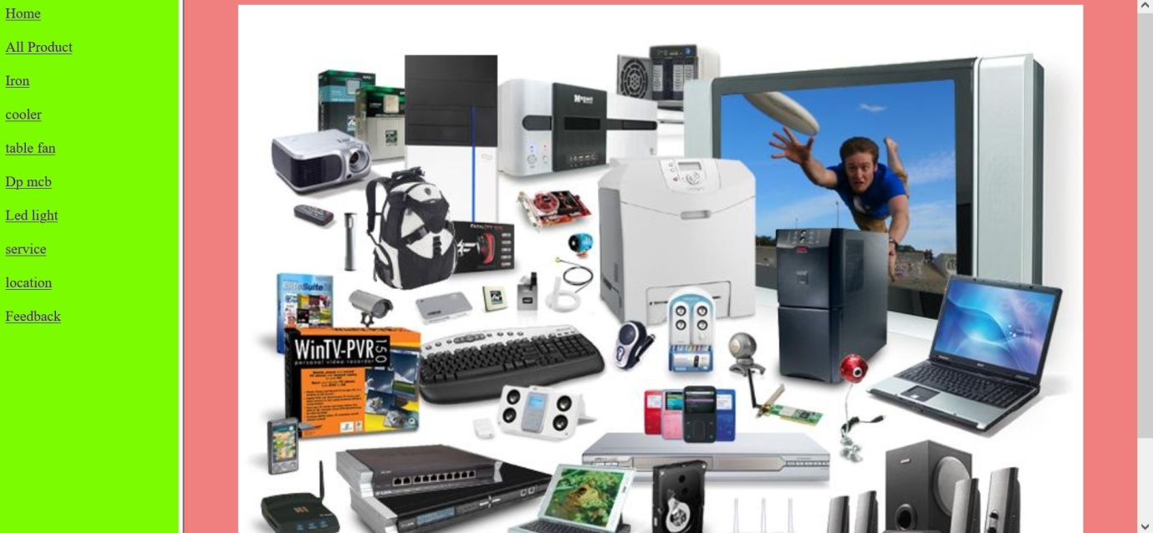

**HOME.HTML**

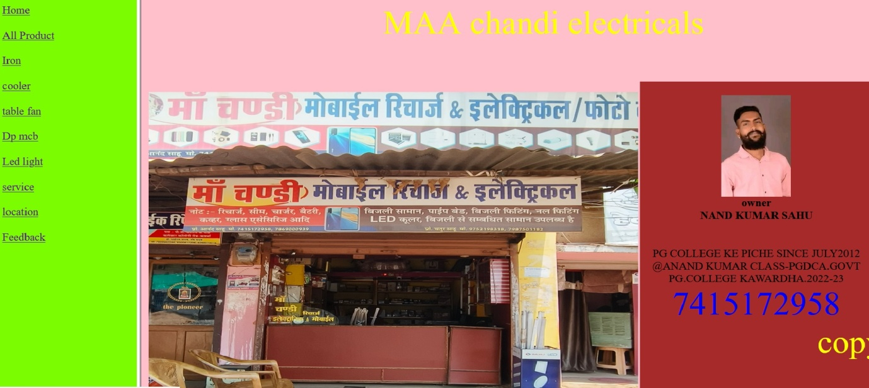

**ALL PRODUCT.HTML**

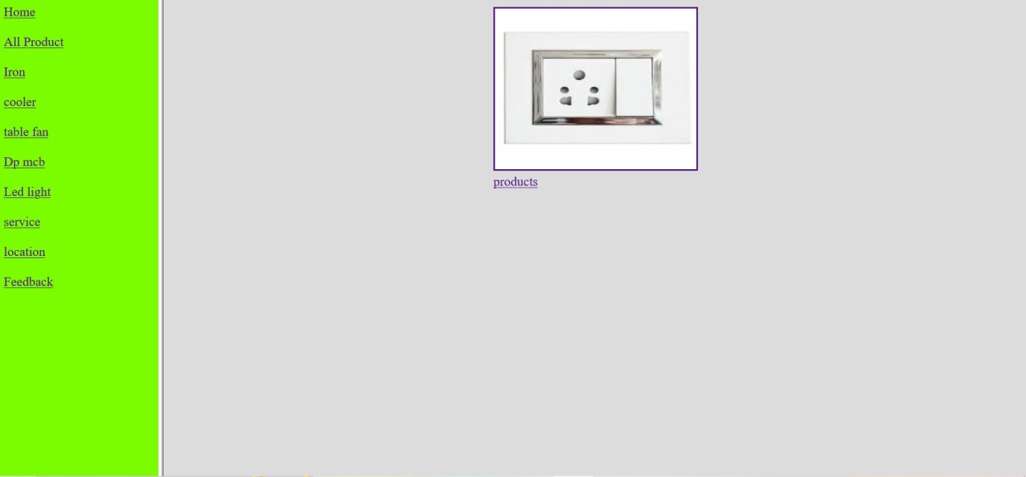

**IRON.HTML**

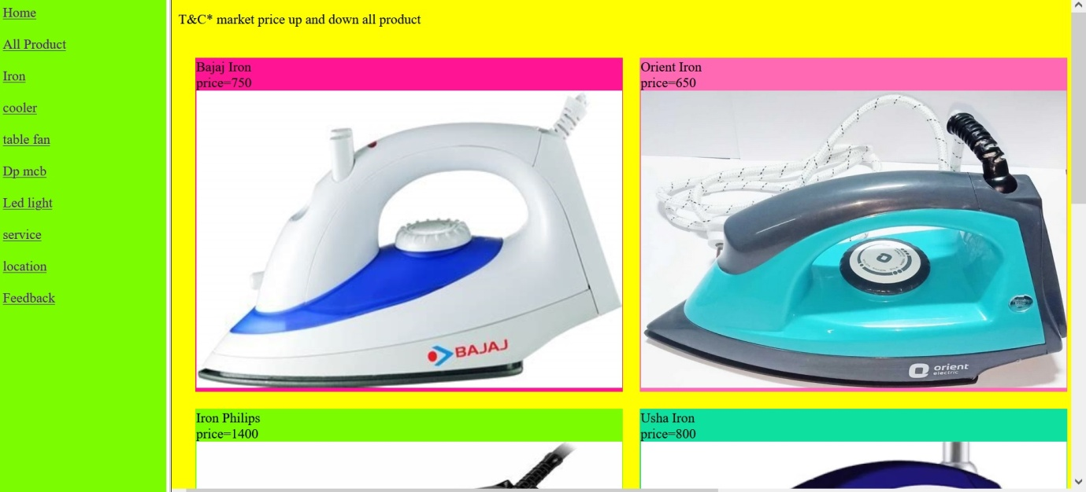**COOLER.HTML**

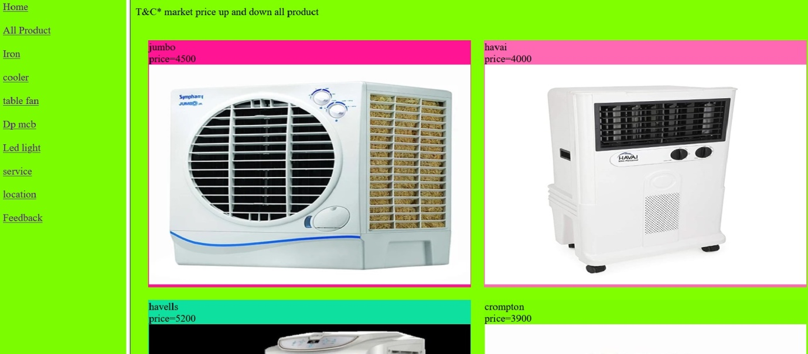

**TABLE FAN.HTML**

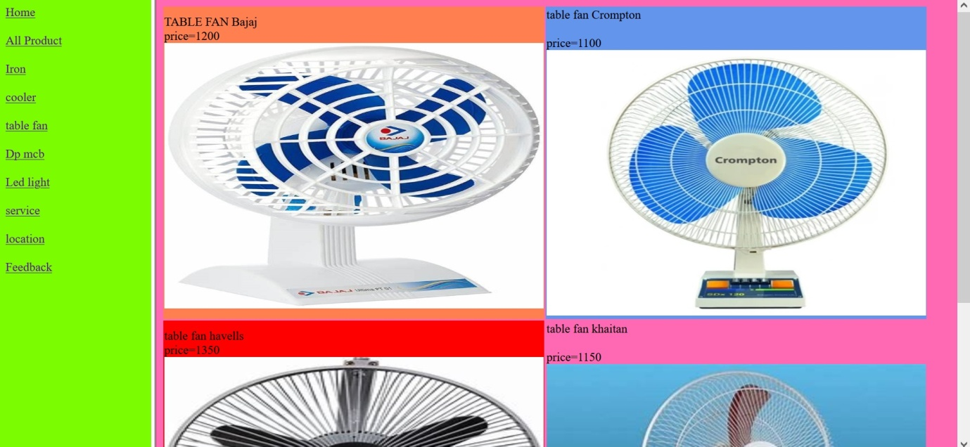**DP MCB.HTML**

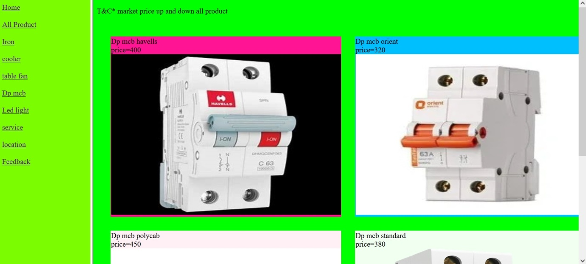

**LED LIGHT.HTML 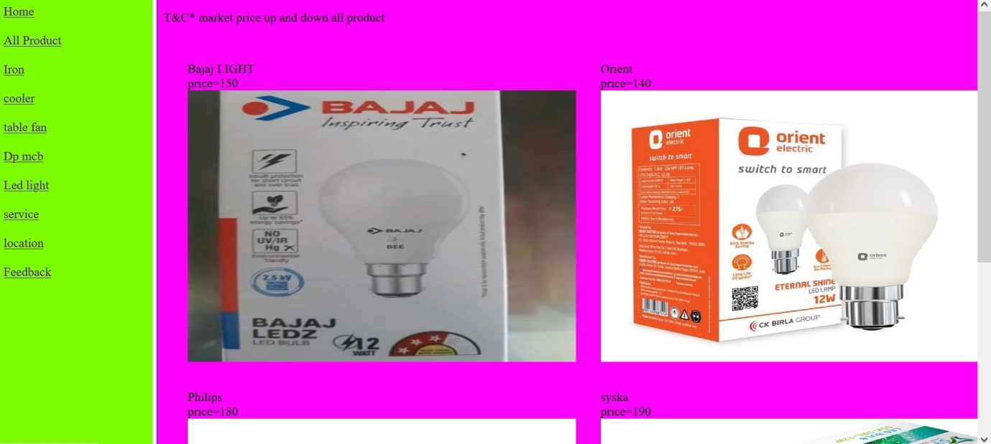SERVICE.HTML**

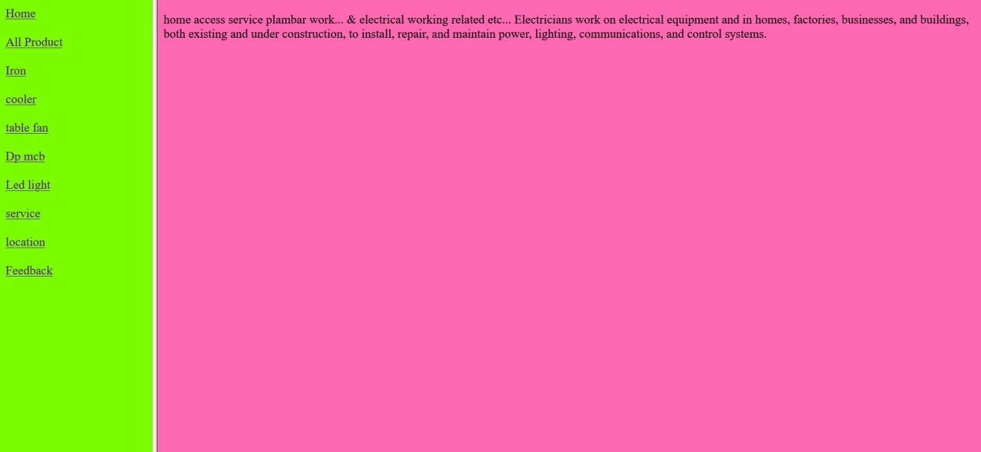

**LOCATION.HTML**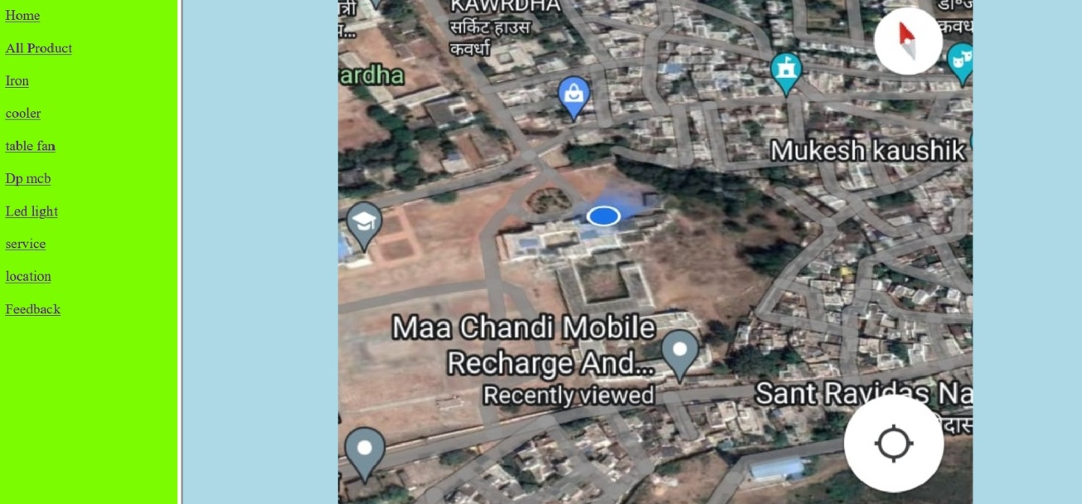

**FEEDBACK.HTML**

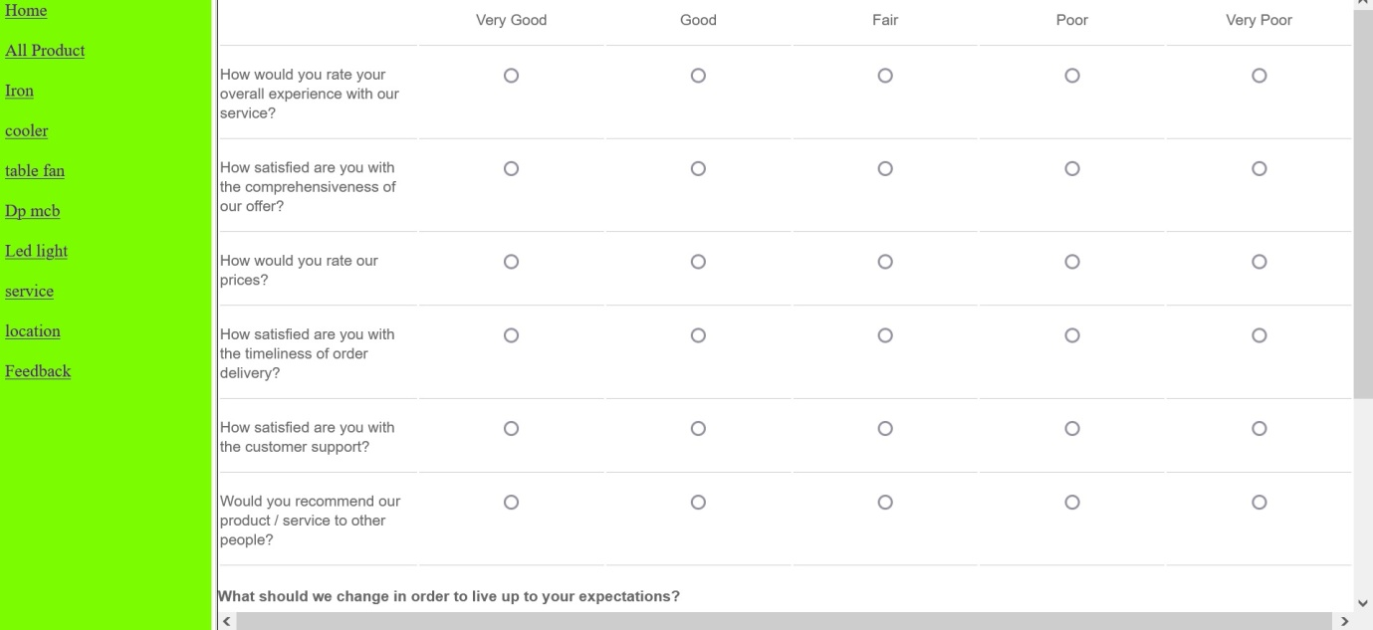

**SOURCE CODE**

**MAIN.HTML**

<!DOCTYPE html>

<html>

<head>

<title>target Frames</title>

</head>

<frameset cols="200,*">

<frame src="[Maa chandi.html](view-source:file:///D:/shop/Maa%20chandi.html)" name="menu_page" />

<frame src="[home.html](view-source:file:///D:/shop/home.html)" name="main_page" />

<noframes>

<body>

Your browser does not support frames.

</body>

</noframes>

</frameset>

</html>

**HOME.HTML**

<!DOCTYPE html>

<html>

<head>

<title>maa chandi</title>

</head>

<body bgcolor="lawngreen">

<a href="[maa chandi electricals/body.html](view-source:file:///D:/shop/maa%20chandi%20electricals/body.html)" target="main_page" >Home</a><br><br>

<a href="[product.html](view-source:file:///D:/shop/product.html)" target="main_page" >All Product</a><br><br>

<a href="[iron.html](view-source:file:///D:/shop/iron.html)" target="main_page">Iron</a><br><br>

<a href="[cooler.html](view-source:file:///D:/shop/cooler.html)" target="main_page">cooler</a><br><br>

<a href="[table fan.html](view-source:file:///D:/shop/table%20fan.html)" target="main_page">table fan</a><br><br>

<a href="[Dp mcb.html](view-source:file:///D:/shop/Dp%20mcb.html)" target="main_page">Dp mcb</a><br><br>

<a href="[led.html](view-source:file:///D:/shop/led.html)" target="main_page">Led light</a><br><br>

<a href="[service/home service.html](view-source:file:///D:/shop/service/home%20service.html)" target="main_page">service</a><br><br>

<a href="[rodmap/rodmap.html](view-source:file:///D:/shop/rodmap/rodmap.html)" target="main_page" >location</a><br><br>

<a href="[feedback.html](view-source:file:///D:/shop/feedback.html)" target="main_page">Feedback</a><br><br>

</body>

</html>

**ALL PRODUT.HTML**

<!DOCTYPE html>

<html>

<head>

<title>product </title>

</head>

<body bgcolor="violet">

<table cellspacing="50%"><p>T&C* market price up and down all product</p>

<tr>

<td bgcolor="aliceblue"> bord<br>price=900<br><img src="[image/bord.jpg](view-source:file:///D:/shop/image/bord.jpg)" alt="Test Image" width="500" height="350"/></td>

<td bgcolor="antiquewhite">cooler<br>price=3500<br><img src="[image/cooler.jpg](view-source:file:///D:/shop/image/cooler.jpg)" alt="Test Image" width="500" height="350"/></td>

</tr>

<tr>

<td bgcolor="bisque">cooler water-pump-<br>price=150<br><img src="[image/cooler water-pump-.jpg](view-source:file:///D:/shop/image/cooler%20water-pump-.jpg)" alt="Test Image" width="500" height="350"/></td>

<td bgcolor="coral">bord2x1<br>price=100<br><img src="[image/bord2x1.jpg](view-source:file:///D:/shop/image/bord2x1.jpg)" alt="Test Image" width="500" height="350"/></td>

</tr>

<tr>

<td bgcolor="chartreuse">bord8<br>price=220<br><img src="[image/bord8.jpg](view-source:file:///D:/shop/image/bord8.jpg)" alt="Test Image" width="500" height="350"/></td>

<td bgcolor="deeppink">dp mcb<br>price=400<br><img src="[image/dp mcb.jpg](view-source:file:///D:/shop/image/dp%20mcb.jpg)" alt="Test Image" width="500" height="350"/></td>

</tr>

<tr>

<td bgcolor="deeppink">fan<br>price=1800<br><img src="[image/fan.jpg](view-source:file:///D:/shop/image/fan.jpg)" alt="Test Image" width="500" height="350"/></td>

<td bgcolor="magenta">iron<br>price=450<br><img src="[image/iron.jpg](view-source:file:///D:/shop/image/iron.jpg)" alt="Test Image" width="500" height="350"/></td>

</tr>

<td bgcolor="gold">LED<br>price=150<br><img src="[image/LED.jpg](view-source:file:///D:/shop/image/LED.jpg)" alt="Test Image" width="500" height="350"/></td>

<td bgcolor="orange">mcb 16<br>price=150<br><img src="[image/mcb 16.jpg](view-source:file:///D:/shop/image/mcb%2016.jpg)" alt="Test Image" width="500" height="350"/></td>

</tr>

<tr>

<td bgcolor="yellowgreen">polycab vayar1.5mm<br>price=900<br>1800<img src="[image/polycab vayar1.5mm.jpg](view-source:file:///D:/shop/image/polycab%20vayar1.5mm.jpg)" alt="Test Image" width="500" height="350"/></td>

</table>

</body>

</html

**IRON.HTML**

<!DOCTYPE html>

<html>

<head>

<title>Iron</title>

</head><p>T&C* market price up and down all product</p>

<body bgcolor="yellow">

<table cellspacing="20">

<tr>

<td bgcolor="deeppink">Bajaj Iron<br>price=750<br><img src="[iron/iron bajaj.jpg](view-source:file:///D:/shop/iron/iron%20bajaj.jpg)" alt="Test Image" width="500" height="350"/></td>

<td bgcolor="hotpink">Orient Iron<br>price=650<br><img src="[iron/iron orient.jpg](view-source:file:///D:/shop/iron/iron%20orient.jpg)" alt="Test Image" width="500" height="350"/></td>

</tr>

<tr>

<td bgcolor="lawngreen"> Iron Philips<br>price=1400<br><img src="[iron/iron philips.jpg](view-source:file:///D:/shop/iron/iron%20philips.jpg)" alt="Test Image" width="500" height="350"/></td>

<td bgcolor="megenta">Usha Iron<br>price=800<br><img src="[iron/Usha iron.jpg](view-source:file:///D:/shop/iron/Usha%20iron.jpg)" alt="Test Image" width="500" height="350"/></td>

<td bgcolor="deeppink">agaro<br>price=750<br><img src="[iron/agaro.jpg](view-source:file:///D:/shop/iron/agaro.jpg)" alt="Test Image" width="500" height="350"/></td>

</tr>

<td bgcolor="deeppink">iron crompton<br>price=750<br><img src="[iron/iron crompton.jpg](view-source:file:///D:/shop/iron/iron%20crompton.jpg)" alt="Test Image" width="500" height="350"/></td>

</tr>

</table>

</body>

</html

**COOLER.HTML**

<!DOCTYPE html>

<html>

<head>

<title>cooler</title>

</head><p>T&C* market price up and down all product</p>

<body bgcolor="chartreuse">

<table cellspacing="20">

<tr>

<td bgcolor="deeppink"> jumbo<br>price=4500<br><img src="[cooler/jumbo.jpg](view-source:file:///D:/shop/cooler/jumbo.jpg)" alt="Test Image" width="500" height="350"/></td>

<td bgcolor="hotpink">havai<br>price=4000<br><img src="[cooler/havai.jpg](view-source:file:///D:/shop/cooler/havai.jpg)" alt="Test Image" width="500" height="350"/></td>

</tr>

<tr>

<td bgcolor="megenta">havells<br>price=5200<br><img src="[cooler/havells.jpg](view-source:file:///D:/shop/cooler/havells.jpg)" alt="Test Image" width="500" height="350"/></td>

<td bgcolor="lawngreen">crompton<br>price=3900<br><img src="[cooler/crompton.jpg](view-source:file:///D:/shop/cooler/crompton.jpg)" alt="Test Image" width="500" height="350"/></td>

</tr>

</table>

</body>

</html

**TABLE FAN.HTML**

<!DOCTYPE html>

<html>

<head>

<title>table fan</title>

</head>

<body bgcolor="hotpink">

<table>

<tr>

<td bgcolor="coral"> TABLE FAN Bajaj <br>price=1200<br><img src="[table fan/fan bajaj.jpg](view-source:file:///D:/shop/table%20fan/fan%20bajaj.jpg)" alt="Test Image" width="500" height="350"/></td>

<td bgcolor="cornflowerblue">table fan Crompton <br><br>price=1100<br><img src="[table fan/Crompton.jpg](view-source:file:///D:/shop/table%20fan/Crompton.jpg)" alt="Test Image" width="500" height="350"/></td>

</tr>

<tr>

<td bgcolor="red"> table fan havells <br>price=1350<br><img src="[table fan/havells.jpg](view-source:file:///D:/shop/table%20fan/havells.jpg)" alt="Test Image" width="500" height="350"/></td>

<td>table fan khaitan<br><br>price=1150<br><img src="[table fan/khaitan.jpg](view-source:file:///D:/shop/table%20fan/khaitan.jpg)" alt="Test Image" width="500" height="350"/></td>

</tr>

</table>

</body>

</html

**DP MCB.HTML**

<!DOCTYPE html>

<html>

<head>

<title>Dp mcb</title>

</head><p>T&C* market price up and down all product</p>

<body bgcolor="lime">

<table cellspacing="30">

<tr>

<td bgcolor="deeppink"> Dp mcb havells <br>price=400<br><img src="[Dp mcb/havells.jpg](view-source:file:///D:/shop/Dp%20mcb/havells.jpg)" alt="Test Image" width="500" height="350"/></td>

<td bgcolor="deepskyblue">Dp mcb orient<br>price=320<br><img src="[Dp mcb/orient.jpg](view-source:file:///D:/shop/Dp%20mcb/orient.jpg)" alt="Test Image" width="500" height="350"/></td>

</tr>

<tr>

<td bgcolor="lavenderblush">Dp mcb polycab <br>price=450<br><img src="[Dp mcb/polycab.jpg](view-source:file:///D:/shop/Dp%20mcb/polycab.jpg)" alt="Test Image" width="500" height="350"/></td>

<td bgcolor="honeydew">Dp mcb standard<br>price=380<br><img src="[Dp mcb/standard.jpg](view-source:file:///D:/shop/Dp%20mcb/standard.jpg)" alt="Test Image" width="500" height="350"/></td>

</tr>

</table>

</body>

</html

**LED.HTML**

<!DOCTYPE html>

<html>

<head>

<title>LED LIGHT</title>

</head><p>T&C* market price up and down all product</p>

<body bgcolor="fuchsia">

<table cellspacing="30">

<tr>

<td>Bajaj LIGHT<br>price=150<br><img src="[led light/bajaj.jpg](view-source:file:///D:/shop/led%20light/bajaj.jpg)" alt="Test Image" width="500" height="350"/></td>

<td>Orient<br>price=140<br><img src="[led light/orient.jpg](view-source:file:///D:/shop/led%20light/orient.jpg)" alt="Test Image" width="500" height="350"/></td>

</tr>

<tr>

<td>Philips<br>price=180<br><img src="[led light/philips.jpg](view-source:file:///D:/shop/led%20light/philips.jpg)" alt="Test Image" width="500" height="350"/></td>

<td>syska<br>price=190<br><img src="[led light/syska.jpg](view-source:file:///D:/shop/led%20light/syska.jpg)" alt="Test Image" width="500" height="350"/></td>

</tr>

</table>

</body>

</html

**SERVICE.HTML**

<!DOCTYPE html>

<html>

<head>

<title>home service</title>

</head>

<body bgcolor="hotpink">

<P>home access service plambar work...

<tr> &</tr>

electrical working related etc...

Electricians work on electrical equipment and in homes, factories,

businesses, and buildings, both existing and under construction,

to install, repair, and maintain power, lighting, communications, and control systems.

</body>

</html>

**TABLE FAN.HTML**

<!DOCTYPE html>

<html>

<head>

<title>Using Image in Webpage</title>

</head>

<body bgcolor="lightblue">

<p></p><center>

<img src="[location shop.jpg](view-source:file:///D:/shop/rodmap/location%20shop.jpg)" hight="50"="10"width="20%" alt="Test Image" /></center>

</body>

</html>

**TABLE FAN.HTML**

<!DOCTYPE html>

<html lang="en">

<head>

<meta charset="UTF-8">

<meta http-equiv="X-UA-Compatible" content="IE=edge">

<meta name="viewport" content="width=device-width, initial-scale=1.0">

<title>feedback</title>

</head>

<body>

<link href='[https://fonts.googleapis.com/css?family=Open+Sans:400,300,300italic,400italic,600](view-source:https://fonts.googleapis.com/css?family=Open+Sans:400,300,300italic,400italic,600)' rel='stylesheet'

type='text/css'>

<link href="[https://fonts.googleapis.com/css?family=Roboto:300,400,500,700](view-source:https://fonts.googleapis.com/css?family=Roboto:300,400,500,700)" rel="stylesheet">

<style>

html,

body {

min-height: 100%;

}

body,

div,

form,

input,

p {

padding: 0;

margin: 0;

outline: none;

font-family: Roboto, Arial, sans-serif;

font-size: 14px;

color: #666;

line-height: 22px;

}

h1 {

font-weight: 400;

}

h4 {

margin: 15px 0 4px;

}

.testbox {

display: flex;

justify-content: center;

align-items: center;

height: inherit;

padding: 3px;

}

form {

width: 100%;

padding: 20px;

background: #fff;

box-shadow: 0 2px 5px #ccc;

}

input {

width: calc(100% - 10px);

padding: 5px;

border: 1px solid #ccc;

border-radius: 3px;

vertical-align: middle;

}

.email {

display: block;

width: 45%;

}

input:hover,

textarea:hover {

outline: none;

border: 1px solid #095484;

}

th,

td {

width: 15%;

padding: 15px 0;

border-bottom: 1px solid #ccc;

text-align: center;

vertical-align: unset;

line-height: 18px;

font-weight: 400;

word-break: break-all;

}

.first-col {

width: 16%;

text-align: left;

}

table {

width: 100%;

}

textarea {

width: calc(100% - 6px);

}

.btn-block {

margin-top: 20px;

text-align: center;

}

button {

width: 150px;

padding: 10px;

border: none;

-webkit-border-radius: 5px;

-moz-border-radius: 5px;

border-radius: 5px;

background-color: #095484;

font-size: 16px;

color: #fff;

cursor: pointer;

}

button:hover {

background-color: #0666a3;

}

@media (min-width: 568px) {

th,

td {

word-break: keep-all;

}

}

</style>

</head>

<body>

<table>

<tr>

<th class="first-col"></th>

<th>Very Good</th>

<th>Good</th>

<th>Fair</th>

<th>Poor</th>

<th>Very Poor</th>

</tr>

<tr>

<td class="first-col">How would you rate your overall experience with our service?</td>

<td><input type="radio" value="none" name="rate" /></td>

<td><input type="radio" value="none" name="rate" /></td>

<td><input type="radio" value="none" name="rate" /></td>

<td><input type="radio" value="none" name="rate" /></td>

<td><input type="radio" value="none" name="rate" /></td>

</tr>

<tr>

<td class="first-col">How satisfied are you with the comprehensiveness of our offer?</td>

<td><input type="radio" value="none" name="satisfied" /></td>

<td><input type="radio" value="none" name="satisfied" /></td>

<td><input type="radio" value="none" name="satisfied" /></td>

<td><input type="radio" value="none" name="satisfied" /></td>

<td><input type="radio" value="none" name="satisfied" /></td>

</tr>

<tr>

<td class="first-col">How would you rate our prices?</td>

<td><input type="radio" value="none" name="prices" /></td>

<td><input type="radio" value="none" name="prices" /></td>

<td><input type="radio" value="none" name="prices" /></td>

<td><input type="radio" value="none" name="prices" /></td>

<td><input type="radio" value="none" name="prices" /></td>

</tr>

<tr>

<td class="first-col">How satisfied are you with the timeliness of order delivery?</td>

<td><input type="radio" value="none" name="timeliness" /></td>

<td><input type="radio" value="none" name="timeliness" /></td>

<td><input type="radio" value="none" name="timeliness" /></td>

<td><input type="radio" value="none" name="timeliness" /></td>

<td><input type="radio" value="none" name="timeliness" /></td>

</tr>

<tr>

<td class="first-col">How satisfied are you with the customer support?</td>

<td><input type="radio" value="none" name="name" /></td>

<td><input type="radio" value="none" name="name" /></td>

<td><input type="radio" value="none" name="name" /></td>

<td><input type="radio" value="none" name="name" /></td>

<td><input type="radio" value="none" name="name" /></td>

</tr>

<tr>

<td class="first-col">Would you recommend our product / service to other people?</td>

<td><input type="radio" value="none" name="recommend" /></td>

<td><input type="radio" value="none" name="recommend" /></td>

<td><input type="radio" value="none" name="recommend" /></td>

<td><input type="radio" value="none" name="recommend" /></td>

<td><input type="radio" value="none" name="recommend" /></td>

</tr>

</table>

<h4>What should we change in order to live up to your expectations?</h4>

<textarea rows="5"></textarea>

<h4>Email</h4>

<small>Only if you want to hear more from us.</small>

<input class="farhinparven2001@gmail.com" type="text" name="Farhin parvin" />

<div class="btn-block">

<button type="submit" href="[/](view-source:file:///)">Send Feedback</button>

</div>

</form>

</div>

</body>

</html>

</body>

</html>

**LIMITATION & FUTURE SCOPE**

**Limitation:**

* The website may not be user-friendly for individuals who are not familiar with technology or who have disabilities that impair their ability to navigate the website.
* Security measures are not perfect and this will have to be implemented.
* The website may not be accessible to individuals who do not have access to the internet or technology.

**Future scope:**

This website can be easily implemented under various situations. We can add new features as and when required. Reusability is possible as and when required in this website. There is still flexibility in all webpages.

**Possible Enhancements:**

The website can be enhanced in a lot many ways in future to make it more scalable and flexible.

* The website can be designed to be more inclusive, incorporating accessibility features such as text-to-speech, large text, and keyboard navigation.
* The website can be integrated with social media platforms to allow for more user engagement and promotion of the website.
* The website can be optimized for mobile devices to ensure that visitors can access the website on the go.
* The website can be expanded to include more comprehensive information about such organization and authority.
* We can include more safety features.

**This project made has gone through various ups and downs during the making of it.I got the ideas about the problems encountered in the analysis, coding, debugging and testing. I have tried to restrict these problems to a certain limit and have tried to make the project more user-friendly and easily to use.**

**CONCLUSION**

It was a wonderful and learning experience for me while working on this project.This project took me through the various phases of project development and gave me real insight into the world of web deveopment. The joy of working as a team and the thrill involved while tackling the various problems and adapting to requirement put forward to us by the user gave us a feel of the developers industry.

It was due to this project I come to know how professionl websites can be designed and what all precautions should be taken.We also found that it is not just the task of an individual, rather a team work, which helped us in making a fine grip on html.

The project has laid the path to the depth of the subject, the require a thorough study and student of computer science have flair to proficiency.We have left no stone unturned while developing this website and making it easy to understand easy to navigate through the web pages and making re-cycling.

I enjoyed each and every bit of work we have put into this project and its successful completion has given me my credit. Also all the problems of manual system are efficiently solved.

**REFERENCES**

*“HTML Black Book” by Mr. Steven Holznar*

*“Web Enabled Commercial Application Development Using HTML” by Mr.Ivan Bayross*

*“Internet, Web Technology & E-Commerce” by Mr. Nitin K. Naik*

*“Computer Science - Internet & E-Commerce” by Mr.Gaurav Sharma*

*Youtube app.*